NAME : PALLAVI NIMMALA

**BASH SCRIPTING – 02**

1. **CASE + SCRIPTS**

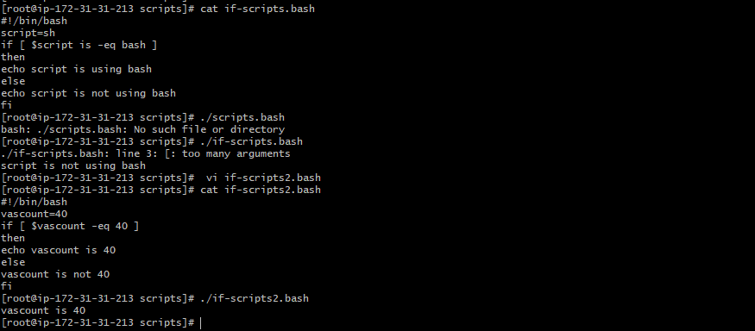

1. **DO-WHILE+ SCRIPTS**

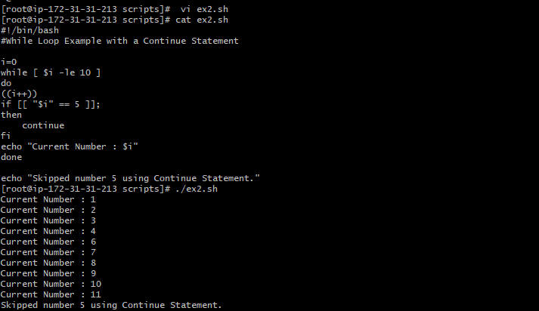

1. **FORLOOP+SCRIPTS**

**Eg 1 :** forloop.sh – using (sh)

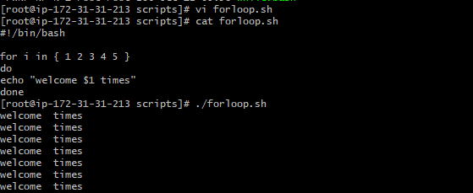

**Eg 2 :** ./forloop.bash

